# Analysis of biophysical impacts of climate extreme shocks on bioeconomy production and consumption activities in EU societies

## Abstract

This paper analyses the biophysical impacts of a bioeconomy (transition) under intensifying patterns of climate extremes. In particular, the focus is on the assessment of vulnerable infrastructures (e.g. food, energy), trade dependencies and consumption activities in the EU. The quantitative approach is based on a historical analysis of crop yields and multiple climate extremes (heat waves, cold waves, droughts, floods) at the sub-national (NUTS-1) level of the EU member states. The crop yield impact analysis provided the empirical basis for the random forest model to predict normalized bioeconomy activity supply and use patterns as a function of climate extreme related crop exposure and crop impact indicators.

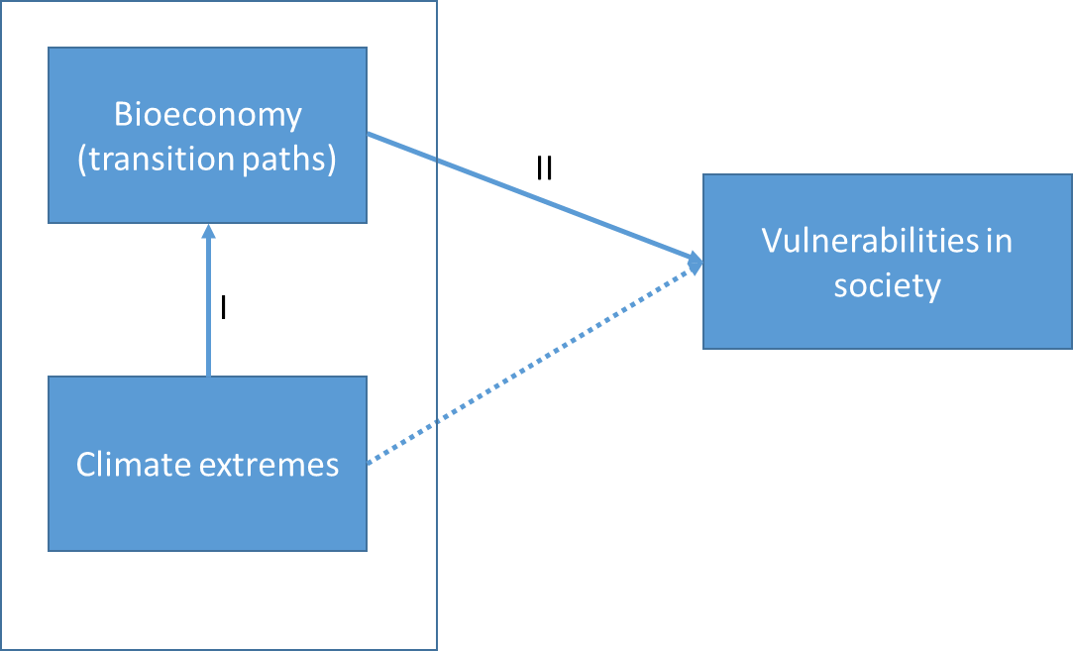

Figure 1: Conceptual model of affected relations (I & II) in a bioeconomy subject to climate extremes

## Methodology

In this paper, the relations between climate extremes, bioeconomy activities and vulnerabilities in society have been assessed from a biophysical perspective. To this end, we first analyzed the relation between climate hazard induced shocks in biomass supply and impacts on bioeconomy activities, followed by the analysis of the potential correlation between climate affected bioeconomy supply chains activities and the impacts and/or vulnerabilities in EU societies. In fact, climate extremes can be regarded as a confounding variable because it also has a direct relation with impacts and vulnerabilities in society. However, in this study, we only take the indirect impacts on society, that is via the use of biomass in bioeconomy (BE) supply chains, into account.

Figure 2 shows the variables and their relations in a two-tier conceptual model. First we assess the relation between crop yields affected by climate extremes in terms of two sets of climate extreme indicators: climate extreme exposure indicators and crop supply shock indicators. This part of the analysis is based on empirical crop yield and climate extreme data, allowing us to identify the years in which climate extremes caused an extreme (90th percentile) supply shock in the time period 1981-2020. Secondly, the extreme supply shocks have been correlated with patterns of bioeconomy activity supply and use of biobased commodities in a ranbdom forest model, thereby providing insights in likely patterns of climate hazard related impacts on food, fed and non-food bioeconomy supply chain activities. The random forest model will be trained for years that have not been affected by climate extremes and for years that have been affected by climate extremes. The resulting analysis has thus been based on the differences between the two random forest models, thereby providing parametric insights on the variance in impact patterns of climate extremes on bioeconomy supply chain activities.

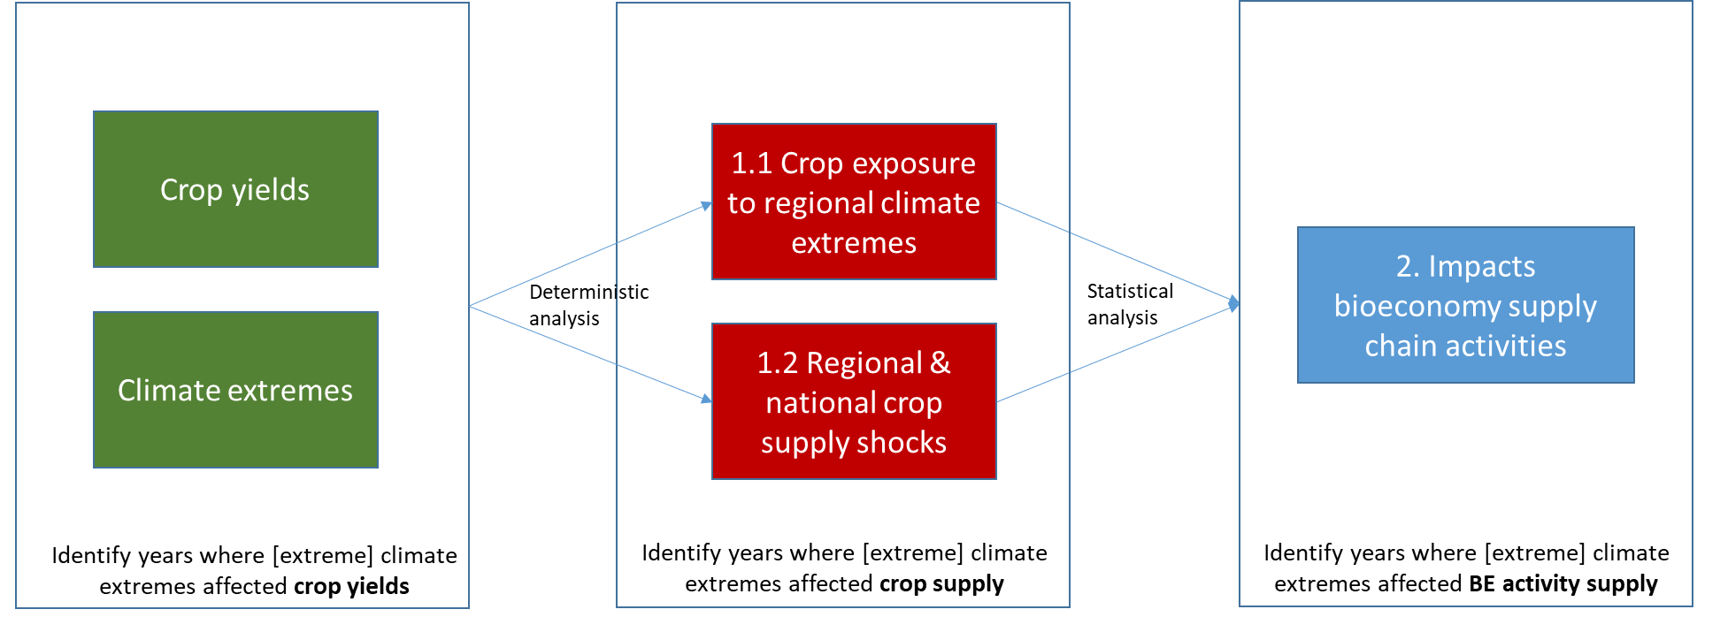

Figure 2: Conceptual model to study the relations between biomass supply shocks and bioeconomy (BE) supply chain impacts subject to climate extremes

Next, we analyzed the relation between bioeconomy supply chain impacts and impacts/vulnerabilities in society as a function of climate extremes shocks in biomass supply (see figure 3). To this end, we have also applied a random forest model to assess the correlations paths between impacts in bioeconomy activity supply and use (independent variables) and the impacts and related vulnerabilities in terms of domestic consumption and trade of food and non-food biobased commodities. Finally, we modeled biophysical impacts and vulnerabilities subject to climate extremes under different RCP scenarios, based on an empirically derived yield damage function (Seydewitz et al. forthcoming) and the bandwidth of robust impact correlations of climate extreme impacts in the EU bioeconomy network.

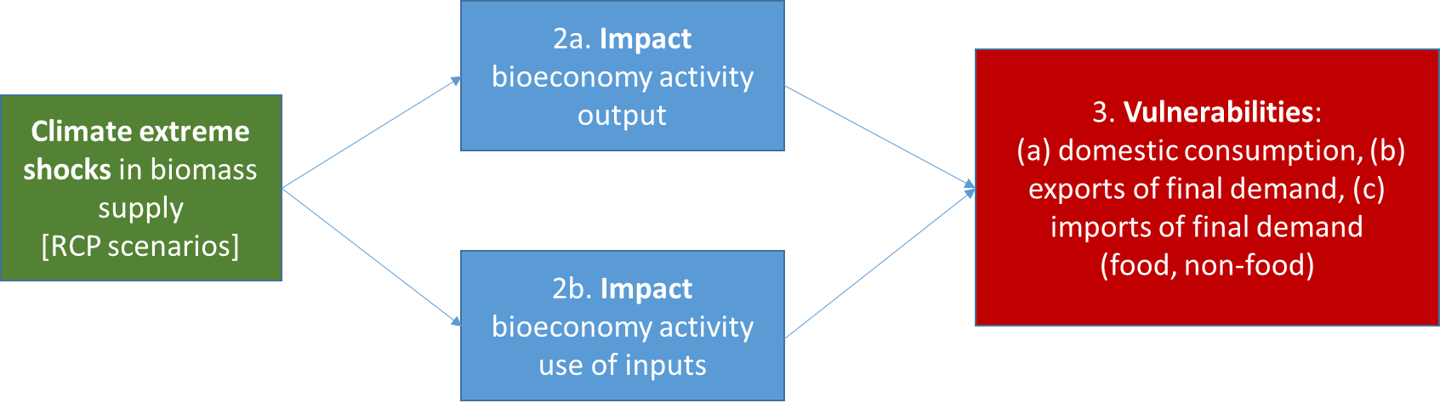

Figure 3: Conceptual model to study the relation between biomass supply shocks, supply chain impacts and societal vulnerabilities in a bioeconomy under different climate extreme scenarios

Table 1 gives an overview of the methodological steps towards the operationalisation of the conceptional model. STEP 1 consists of the definition and construction of indicators of shocks in biomass supply due to climate extremes. This concept has been operationalised by means of two indicators: (1) regional crop exposure to different climate extremes, and (2) crop supply impacts due to yield damages. By combining the two indicators, the analysis will render the years in which there has been a co-occurence of a regional climate extreme and an extreme (yield) damage in crop supply.

Data for climate extremes has been extracted from the Copernicus ER 5 land database[1] for heat waves, cold waves and droughts. For floods, we have used the International disaster database EM-DAT[2] and, finally, a fire weather index has been calculated as a composite indicator of heat waves and droughts (Seydewitz et al. forthcoming). All weather indices have been aggregated from the grid (0.1° x 0.1°) level towards the NUTS1 level for the EU member states and the UK. Weather extreme thresholds are set at the minimum of three consecutive days and the extreme weather index is an annual index that sums all days of climate extremes that exceed the minimum threshold. The extreme weather index used for the construction of the crop exposure indicator is based based on the 90th percentile of extreme events in the period 1981-2020 (rendering “extreme extreme events” for each extreme weather index in the time series). It should be noted that the baseline climate pattern covers the 1981-2010 period, resulting in a bias towards extreme events in the years after 2010 (due to climate warming).

Data for the sub-national biomass yields and harvested production of agricultural crops has been extracted from EUROSTAT (Eurostat, 2020). As the supply shock from climate extremes is assumed to be related to yield damages, we calculated a normalized yield damage index from the actually recorded yield in a certain year as compared to the 5 year rolling yield average (to include productivity increases in crop yield over time). The normalized yield damage has been applied to the harvested production of a specific crop, thereby providing the (absolute) indicator for the potential crop loss at the NUTS 1 level due to the aggregated pattern of extreme events in a specific year.

STEP 2 consists of the definition and construction of the response variable (to supply shocks in crops/wood) in the EU bioeconomy. Unfortunately, there are no databases available that show a consistent time series of sub-national output and/ or inputs of bioeconomy activities. Such data are only available from national level databases such as FAOSTAT[3]. For our initial analysis, we used the biophysical supply and use tables of bioeconomy activities in the FABIO (Bruckner et al. 2018) and FORBIO (Rosadio Cayllahua et al. forthcoming) input output databases. On the supply side, the total output of primary and secondary (manufacturing) supply chain activities have been correlated with the climate extreme shock indicators from step 1. Furthermore, to be able to analyse a deeper layer of the global trade structure in the EU bioeconomy, The climate extreme shock indicators will be correlated with the use of biobased commodities by food, animal feed and non-food bioeconomy supply chain activities in the EU bioeconomy.

STEP 3 involves the statistical analysis of (1) the supply shocks in harvested biomass production due to climate extremes and the impacts on bioeconomy supply chain activities and (2) the correlation between the latter and the impacts on final consumption in random forest models. As mentioned above, we calculated the climate extreme shock indicators at the sub-national (NUTS 1) level, whereas the bioeconomy activity variables are available at the national level. As there was no possibility to disaggregate the bioeconomy activities to the sub-national level, we have aggregated the regional climate shock indicators to the national level, i.e. national crop exposure shares and net supply impacts. This has the advantage that crops with poor data coverage at the sub-national level could be complemented with national level data from Eurostat and/or FAOSTAT and cover a larger time series of national supply shocks due to climate extremes. However, in order to exploit the potential information hidden in the reginal level data, the random forest model initially included both regional and national climate extreme indexes, as well as a multiregional supply shock indicator based on the sum of national supply shocks (see Figure 4)

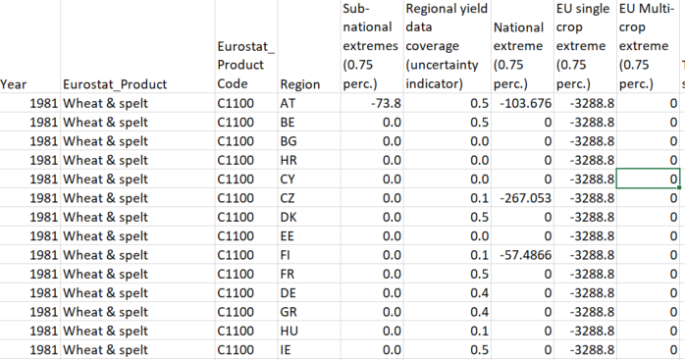

Figure 4: Head of Climate extreme crop supply impact database (full database available at Github)

In STEP 4, we have adapted the model with the variables that explain the majority share of the variance in the response variables. The resulting bandwith in correlation patterns can then be applied to different scenarios of climate extremes (STEP 7), taking the robustness of the relations (STEP 5) and uncertainty from the aggregation method (STEP 6) into account.

Table 1: Methodological steps towards the operationalization of concepts

|  |  |  |
| --- | --- | --- |
| STEP | SUBSTEP | CALCULATIONS |
| 1. Definition and construction of indicators | * 1. Definition of climate extreme indicator   2. Definition of climate extreme impact indicator | 1.1a. Regional level crop exposure to 4 different climate extremes (%)  1.2a. Deviation actual crop supply from 5 yr. rolling average (1,000 t) |
| 1. Definition and construction of dependent variables | * 1. Total output of bioeconomy supply activities (from FABIO/FORBIO)   2. Total use of biobased inputs by bioeconomy supply activities (from FABIO/FORBIO) |  |
| 1. Statistical analysis | * 1. Analysis of relation climate extremes, shocks in crop/wood supply and impact bioeconomy activity output   2. Analysis of relation climate extremes, shocks in crop/wood supply and impact bioeconomy activity use | 3.1a & 3.2a. . Identification crop sensitivity to different climate extremes  3.1b & 3.2b. Min-max levels of shock in crop supply in relation to 5yr rolling average |
| 1. Validation of analysis |  | 4a. Machine learning (random forest) |
| 1. Validation of aggregation method |  |  |
| 1. Validation of robustness & sensitivity |  |  |
| 1. Application of the impact index to the spatial & temporal scale |  |  |

1. <https://cds.climate.copernicus.eu/cdsapp#!/dataset/reanalysis-era5-land?tab=form>
2. <https://www.emdat.be/>
3. <https://www.fao.org/faostat/en/#data>